**FLIGHT MANAGEMENT SYSTEM**

**INTRODUCTION**

In our project “Flight Management System” we have tried to show how the data/information in flights is managed. This is just an overview of management in flights. It manages and maintains the records of customers, place of take off and final destination, and their luggage and total price. Main aim of this project is to provide a solution for customers and airline to manage most of their work using computerized process.

The project, Flight management system is a desktop-based application that allows to handle all flight related activities online. Interactive interface and the ability to manage customers information, destination and takeoff places and information regarding luggage make this system convenient and easy.

ER Diagram: Entity Relationship Diagram Of Project-

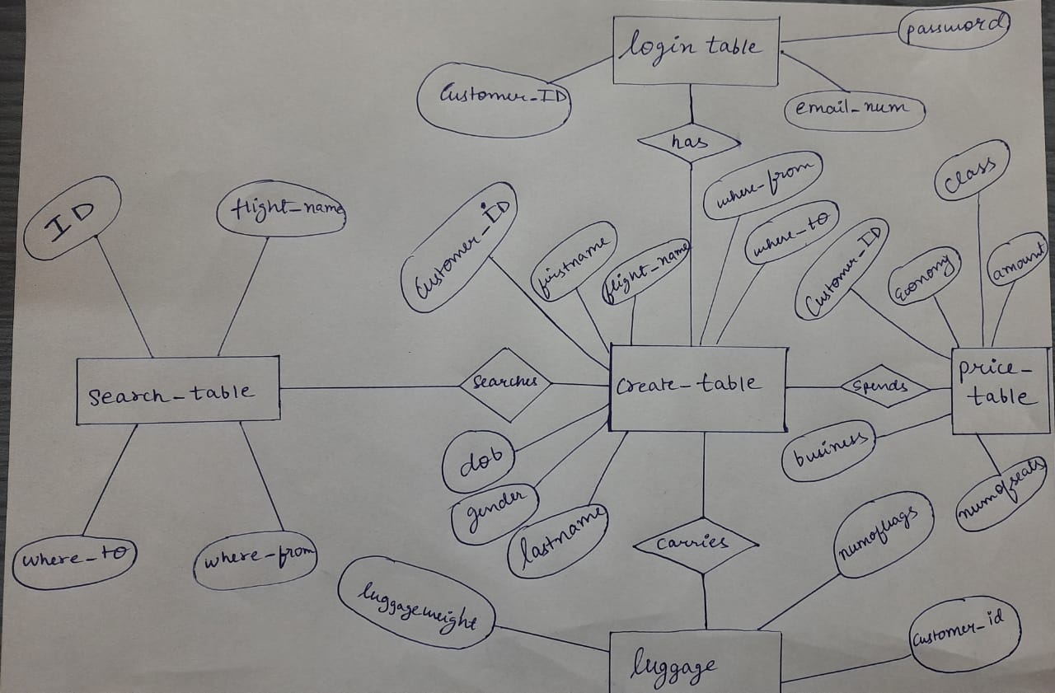

SQL TABLES USED-

1. search_table( ID, where_to, where_from, Flight_Name)
2. login_table( Customer_ID, email_num, password)
3. create_ table( Customer_id, firstname, lastname, dob, where_from, where_to, flight_name, gender)
4. luggage( Customer_id, numofbags, luggageweight)
5. price_table( Customer_id, economy, class, bussiness, numofseats, amount)